ARTIFICIAL NEURAL NETWORKS
MID-SEM QUICK REVISION NOTES
Units 1–5 • Definitions • Key formulas • Intuition • Diagrams

1. 1-Minute Formula Sheet
Topic | Formula / fact
Linear neuron | z = Σ wᵢxᵢ + b
Linear regression | ŷ = wᵀx + b
MSE | MSE = (1/n) Σ(yᵢ − ŷᵢ)²
Gradient descent | θ ← θ − η ∇J(θ)
Sigmoid | σ(z)=1/(1+e⁻ᶻ), σ′(z)=σ(z)[1−σ(z)]
tanh | tanh′(z)=1−tanh²(z)
ReLU | max(0,z), derivative: 1 if z>0 else 0
L1 penalty | λ Σ|wᵢ|
L2 penalty | λ Σwᵢ²
Regularized cost | J = data loss + penalty
Neuron decision | step(wᵀx+b): output 1 if z≥0, else 0
Backprop idea | forward pass → loss → chain rule gradients → update weights

UNIT 1 — Neuron & Basic Neural Networks

Linear Regression
- Predicts a continuous numerical value using a linear relationship between inputs and output.
- Example: house price = w₁(area) + w₂(rooms) + b.
- A single linear neuron can represent the same equation.
ŷ = w₁x₁ + w₂x₂ + … + wₙxₙ + b = wᵀx+b

Classification Regions
- Classification divides the input space into regions belonging to different classes.
- A single neuron with a step/sign decision creates a straight-line (2D), plane (3D), or hyperplane decision boundary.
- Points on one side → one class; the other side → another class.
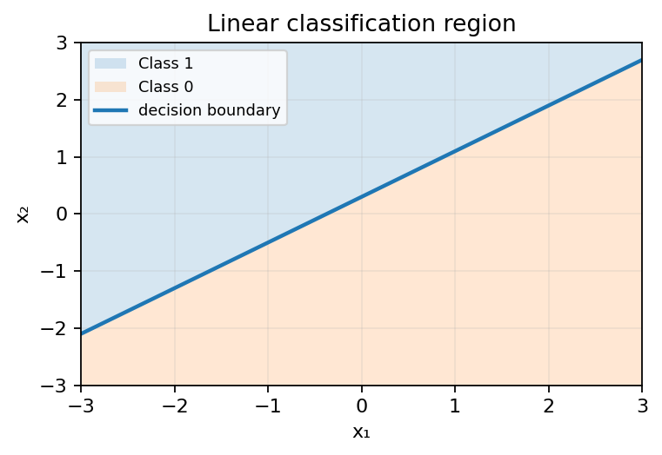

Neural Network as a Collection of Lines
- Each linear neuron computes a weighted sum, so its decision boundary is a line/hyperplane.
- Multiple neurons can create multiple boundaries; combining them can form more complex regions.
- This is the geometric view of neural networks.

Matrix Multiplication
- Vector/matrix form makes many neuron calculations compact and efficient.
- For one layer: z = Wx + b.
- For a batch of examples, matrix multiplication computes many neurons/examples together.
If W is m×n and x is n×1, then Wx is m×1.

Biological / Human Neuron
- Dendrites receive signals; the cell body combines them; the axon sends the output.
- A neuron fires when the combined input reaches sufficient activation.

Artificial Neuron
- Mathematical model inspired by a biological neuron.
- Inputs are multiplied by weights, added together with bias, then passed through an activation function.
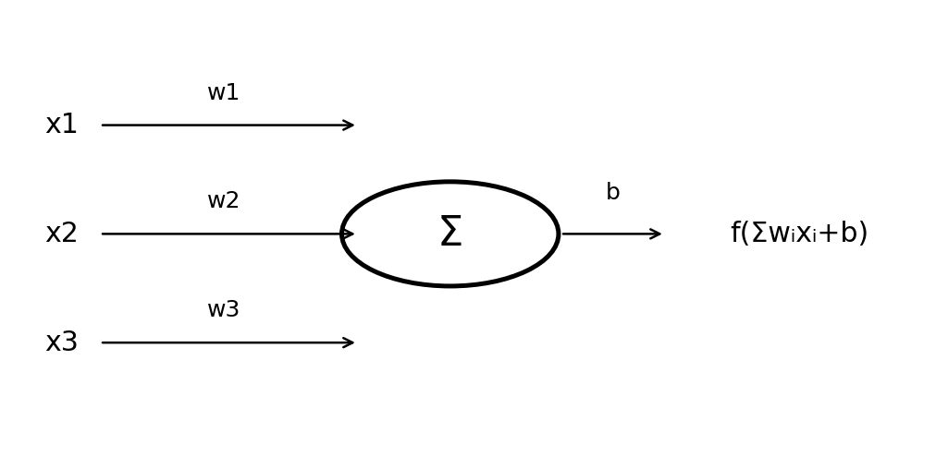

Inputs and Weights
- xᵢ = input feature/signal.
- wᵢ = importance/sign of that input.
- Large positive weight strengthens the input; negative weight suppresses/reverses it.

Weighted Summation
- Multiply each input by its weight and add them.
- Bias is added before activation.
z = Σ wᵢxᵢ + b

Threshold
- A threshold decides whether a neuron activates.
- For a binary step neuron: output 1 when z ≥ 0, otherwise 0.
- Threshold can be written as a separate value θ: output 1 if Σwᵢxᵢ ≥ θ.

Bias
- Bias shifts the decision boundary left/right (or generally changes its position).
- Without bias, a linear decision boundary is forced to pass through the origin.
z = wᵀx + b

Boolean Gates — AND, OR, NOT
- Boolean gates take binary inputs (0/1) and produce a binary output.
- AND → 1 only when both inputs are 1.
- OR → 1 when at least one input is 1.
- NOT → flips the input: 0→1 and 1→0.
- A single threshold neuron can implement AND, OR and NOT because their classes are linearly separable.
x₁ | x₂ | AND | OR | NOT (x₁)
0 | 0 | 0 | 0 | 1
0 | 1 | 0 | 1 | 1
1 | 0 | 0 | 1 | 0
1 | 1 | 1 | 1 | 0

Basic Network Representation
- Input layer receives features.
- Connections carry weights.
- Neurons calculate weighted sums + bias and activation.
- Output layer produces prediction/class.

Basic Classification Using Neurons
- Compute z = wᵀx+b.
- Apply activation/threshold.
- The sign of z determines which side of the decision boundary the point lies on.

UNIT 2 — Error, Cost & Optimization

MSE — Mean Squared Error
- Measures average squared difference between true values and predictions.
- Squaring makes all errors positive and penalizes large errors more strongly.
- Lower MSE means predictions are closer to targets.
MSE = (1/n)Σ(yᵢ−ŷᵢ)²

Cost Function
- A single number that tells how bad the model's predictions are.
- Training tries to minimize the cost.
- For regression, MSE is a common cost/loss choice.

Error Minimization
- Goal: find weights/biases that make the loss as small as possible.
- Visualize cost as a surface: training moves toward a low point/minimum.

Basic Parameter Optimization
- Parameters = weights and biases.
- Gradient tells the direction of greatest increase in cost.
- Move in the opposite direction to reduce cost.
θ_new = θ_old − η(∂J/∂θ) ; η = learning rate

Basic Error-Related Learning Concept
- Prediction error generates a learning signal.
- Gradient-based learning changes parameters so future predictions reduce the error.
- Learning rate controls step size: too large may overshoot; too small makes learning slow.

Regularization / Penalty Concept
- Regularization discourages overly large/complex weights.
- It adds a penalty term to the original loss.
- Purpose: reduce overfitting and improve generalization.
Regularized cost = data loss + λ × penalty

UNIT 3 — Regression, Classification & Multilayer Networks

Linear Regression
- Output is continuous.
- Model is a weighted sum of input features plus bias.
- Typically trained by minimizing MSE.
ŷ = wᵀx+b

MSE-Based Optimization
- Compute predictions → calculate MSE → calculate gradients → update w and b → repeat.
- The process is gradient descent when updates use the negative gradient.

Linear Classification
- Used for class labels such as 0/1.
- A linear classifier uses z=wᵀx+b and a threshold/appropriate activation.
- Its decision boundary is wᵀx+b=0.

Classification Regions
- The boundary separates input space into class regions.
- One linear neuron can create only one hyperplane boundary.
- Non-linear problems such as XOR need multiple boundaries/layers.

Basic Multilayer Network
- A multilayer neural network contains input, one or more hidden layers, and an output layer.
- Hidden layers transform the input into increasingly useful representations.
- Nonlinear activation functions let the network represent nonlinear boundaries.
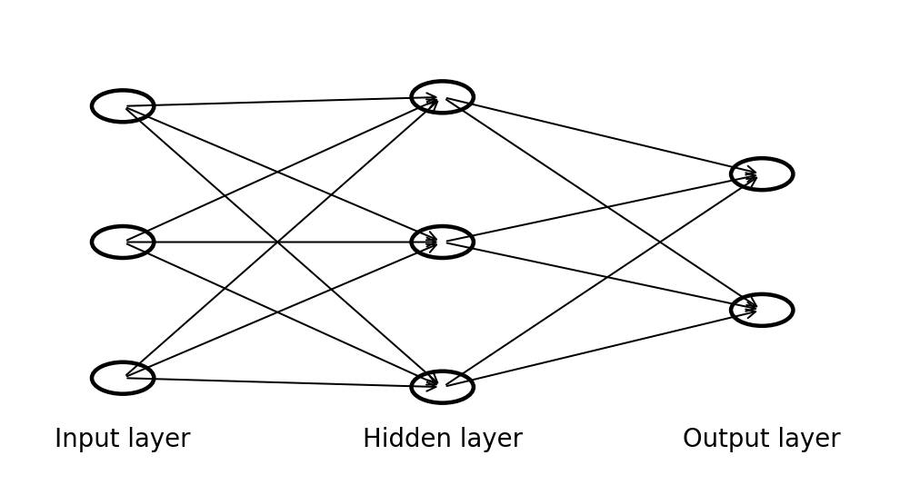

Input Layer
- Receives the feature values; usually does not perform a learned transformation itself.

Hidden Layer
- Intermediate neurons that learn combinations/features from previous layer.
- Multiple hidden layers form a deep neural network.

Output Layer
- Produces final prediction.
- Typical binary classification: one output neuron with sigmoid.
- Regression: often one linear output neuron.

UNIT 4 — Backpropagation, XOR & Activations

Backpropagation Algorithm
- Efficient method for computing gradients of the loss with respect to every weight/bias.
- Steps: 1) forward pass, 2) calculate loss, 3) propagate error backward using chain rule, 4) update parameters.
- Backpropagation computes gradients; gradient descent uses those gradients to update parameters.

XOR Problem
- XOR output is 1 when inputs are different and 0 when they are the same.
- Its positive and negative examples cannot be separated by one straight line.
- Therefore a single perceptron/linear neuron cannot solve XOR.
- A multilayer network with nonlinear activation can solve it.
x₁ | x₂ | XOR
0 | 0 | 0
0 | 1 | 1
1 | 0 | 1
1 | 1 | 0

Boolean-Function Implementation
- A truth table defines desired output for every input combination.
- Design neurons/gates that reproduce those mappings.
- AND/OR/NOT are linearly separable; XOR requires a combination of intermediate decisions.

Truth-Table Based Neural Network
- List all input combinations and desired outputs.
- Choose neuron weights/biases so the activation matches each row.
- For multi-step Boolean functions, use hidden neurons to implement intermediate functions.

AND / OR / NOT Implementation
- Use a binary step activation.
- AND example: z=x₁+x₂−1.5 → step(z).
- OR example: z=x₁+x₂−0.5 → step(z).
- NOT example: z=−x+0.5 → step(z).

Decision / Classification Regions
- A neuron creates a boundary; a network combines boundaries to create complex shapes.
- The region where the output is 1 is the positive/class-1 region.

Polygon Representation
- Multiple linear boundaries can enclose a polygonal classification region.
- Each neuron can represent one half-plane; ANDing conditions keeps only their intersection.

Triangle Representation
- Three line boundaries can form a triangular region.
- A hidden neuron can test each half-plane; an output neuron can combine them.

Square Representation
- Four line boundaries can form a square/rectangle.
- Each boundary corresponds to a linear inequality.

Combination of Polygons
- OR-like combinations can create unions of regions.
- AND-like combinations can create intersections.
- This gives multilayer networks their geometric flexibility.

Activation Functions

Binary Step
- Hard threshold; useful for simple Boolean/perceptron logic.
- Not differentiable at 0 and derivative is 0 almost everywhere, so it is unsuitable for standard gradient-based deep training.
f(z) = 1 if z≥0 else 0
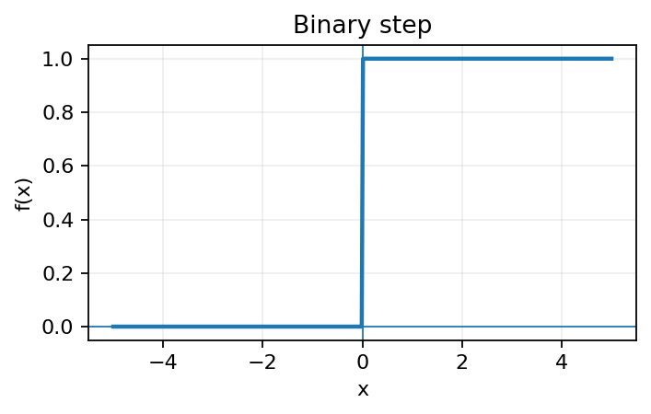

ReLU
- Keeps positive values and converts negative values to 0.
- Fast and common in hidden layers.
- Can suffer from 'dying ReLU' when neurons remain on the negative side.
ReLU(z)=max(0,z)
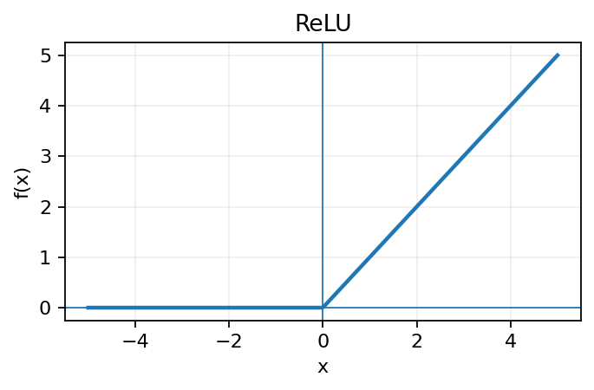

Sigmoid
- Maps any real number to (0,1).
- Useful for binary-class probability-like outputs.
- Can have very small gradients for large positive/negative z (vanishing gradient).
σ(z)=1/(1+e⁻ᶻ), σ′(z)=σ(z)(1−σ(z))
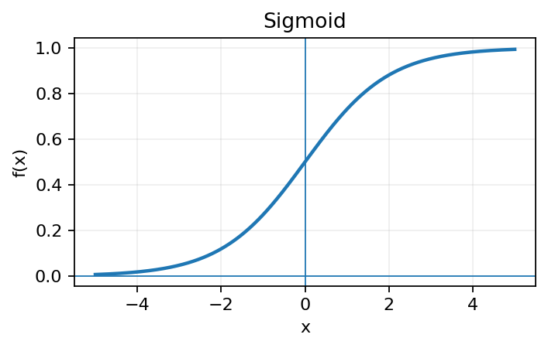

Leaky ReLU
- Like ReLU, but gives a small negative slope instead of zero for negative inputs.
- Helps reduce dead neurons.
f(z)=z if z≥0; αz if z<0, usually small α
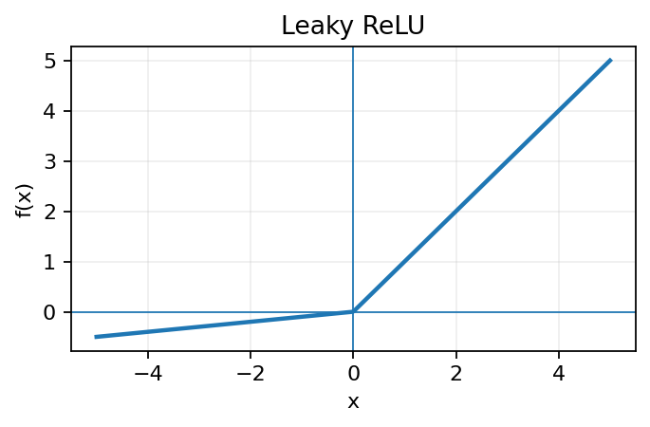

tanh
- Maps values to (−1,1).
- Zero-centered, unlike sigmoid.
- Can still suffer from vanishing gradients for large |z|.
tanh′(z)=1−tanh²(z)
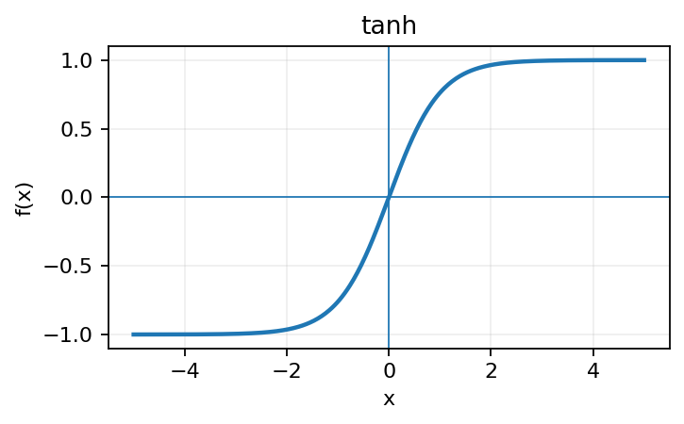

Basic Multilayer Network Training
- Initialize weights → forward pass → calculate loss → backpropagate gradients → update weights → repeat for many iterations/epochs.
- Training is complete when loss is sufficiently low and validation performance is satisfactory.

UNIT 5 — Detailed Backpropagation & Regularization

Backpropagation
- Uses the chain rule to determine how much each parameter contributed to the final error.
- Start from output error and move backward layer by layer.
For a parameter w: ∂L/∂w = (∂L/∂output) × (∂output/∂z) × (∂z/∂w)

Differentiation
- Derivative tells how much a quantity changes when its input changes.
- In neural networks, derivatives provide the direction and magnitude needed for parameter updates.

Chain Rule
- Used when one function depends on another function.
- Multiply local derivatives along the path from a parameter to the loss.
If y=f(g(x)), then dy/dx = (dy/dg)(dg/dx)

Sigmoid Differentiation
- The sigmoid derivative can be written using the sigmoid output itself.
- This makes backpropagation computationally convenient.
σ′(z)=σ(z)[1−σ(z)]

Error Calculation
- Compare prediction ŷ with target y using the chosen loss.
- For MSE, the error is squared difference; for many classification models, cross-entropy is commonly used.
MSE sample loss: L = ½(y−ŷ)² → ∂L/∂ŷ = ŷ−y

Output-Layer Derivatives
- For an output neuron, compute loss derivative with respect to output.
- Multiply by activation derivative to obtain derivative with respect to pre-activation z.
- Then propagate to weights and inputs.

Hidden-Layer Derivatives
- A hidden neuron affects the loss indirectly through the next layer.
- Its gradient is the downstream gradient multiplied by its local activation derivative.
- This is why chain rule is central to backpropagation.

Weight Derivatives
- For z=wᵀx+b, ∂z/∂w = x.
- Therefore weight gradient is closely related to input activation × downstream error.
∂L/∂w = δx and ∂L/∂b = δ

Weight Update
- Move weights opposite to the gradient.
- Repeat over training examples/batches.
w ← w − η(∂L/∂w)

Matrix-Based Backpropagation Calculations
- For layer l: zˡ=Wˡaˡ⁻¹+bˡ and aˡ=f(zˡ).
- Output/hidden error vector: δˡ = (Wˡ⁺¹)ᵀδˡ⁺¹ ⊙ f′(zˡ).
- Gradients: ∂L/∂Wˡ = δˡ(aˡ⁻¹)ᵀ and ∂L/∂bˡ = δˡ.
- ⊙ means element-wise multiplication.
Core forward equations: zˡ=Wˡaˡ⁻¹+bˡ ; aˡ=f(zˡ)

Overfitting
- Model learns training data too closely, including noise or accidental patterns.
- Training error becomes low while performance on unseen data is worse.
- Common controls: more data, simpler model, early stopping, dropout, and regularization.

Training vs Testing Performance
- Training set: used to learn parameters.
- Validation set: used for tuning/model selection.
- Test set: final unbiased estimate on unseen data.
- Typical overfitting pattern: training loss ↓ while validation/test loss eventually ↑.

L1 Regularization
- Adds the absolute values of weights to the loss.
- Encourages sparse solutions; some weights may become exactly zero.
J_regularized = J_data + λΣ|wᵢ|

L2 Regularization
- Adds squared weights to the loss.
- Encourages small weights and generally spreads information across parameters rather than forcing exact zeros.
J_regularized = J_data + λΣwᵢ²

Penalty Function
- Penalty is the extra term added to discourage model complexity.
- λ controls strength: larger λ → stronger pressure toward smaller weights.
- L1 → absolute-value penalty; L2 → squared-weight penalty.

2. Exam-Day Checklist
- Know neuron equation: z=wᵀx+b and output a=f(z).
- Know why bias is needed: it shifts the decision boundary.
- Know why one linear neuron cannot solve XOR.
- Know the roles of input, hidden and output layers.
- Know MSE and gradient-descent update.
- Know all five activations: step, ReLU, sigmoid, leaky ReLU, tanh.
- Know backprop order: forward → loss → chain rule → gradients → update.
- Know sigmoid derivative: σ(1−σ).
- Know matrix backprop: δˡ=(Wˡ⁺¹)ᵀδˡ⁺¹⊙f′(zˡ).
- Know overfitting signs and L1 vs L2 difference.
- For Boolean questions, start from the truth table and construct threshold conditions.
- For geometry questions, remember: one neuron = one half-plane; multiple neurons = combined regions/polygons.

